Name – Vaibhav Khandekar

PRN No. – 230340325073

**Set B**

Shell Script

1. Write a shell program to find the second largest number in a list of integers.

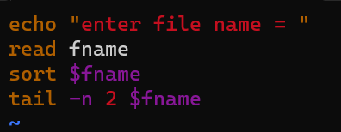

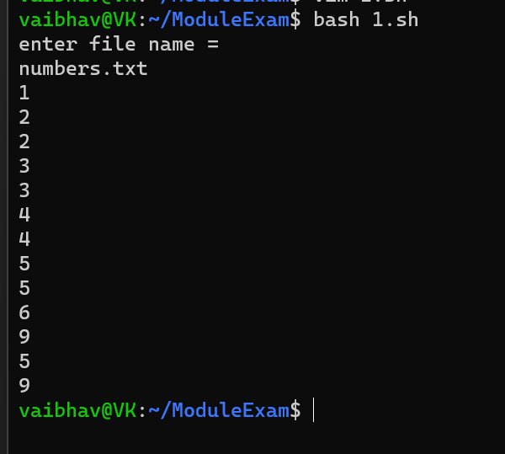

1. Write a shell command using chmod to give the owner of a file named file.txt read, write and execute permissions and give the group and others only read permissions.

**Ans**

chmod 744 file.txt

ls -l file.txt

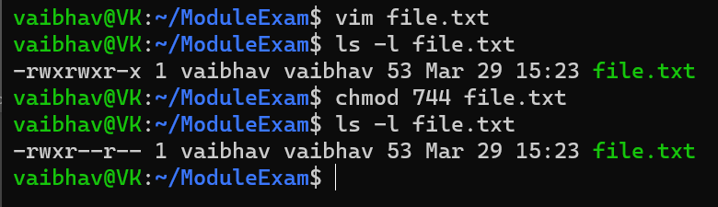

1. Create a directory named backup in your home directory. In this directory, create a sub-directory named daily and another sub-directory named weekly. Create a file named backup.txt in the daily sub-directory.

**Ans**

Step 1. cd ~ - It will move you to the home directory.

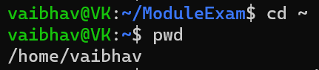

Step 2. mkdir -p backup/{daily,weekly} – It will create parent directory structure.

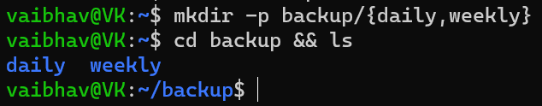

Step 3. cat > daily/backup.txt – It will create backup.txt in ‘daily’ sub-directory.

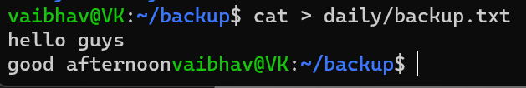

1. Copy the file backup.txt to the to the weekly sub-directory.

**Ans**

cp daily/backup.txt weekly/ -

It will copy your backup.txt file to /backup/weekly

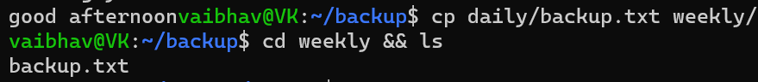

1. Rename the copied file in the weekly sub-directory as backup_weekly.txt.

**Ans**

rename ‘s/backup/weekly_backup/’ backup.txt –

It will rename your file name from ‘backup.txt’ to ‘weekly_backup.txt’.

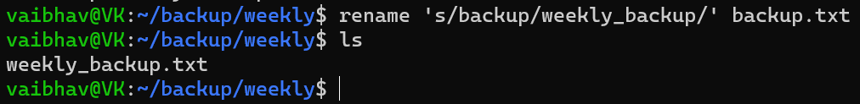

1. Change the permission of the original file backup.txt file to read-only for the owner and group and no permissions for the others.

**Ans**

chmod 440 backup.txt –

440 is the octal code for read only permissions for owner and groups and no permissions for the others.

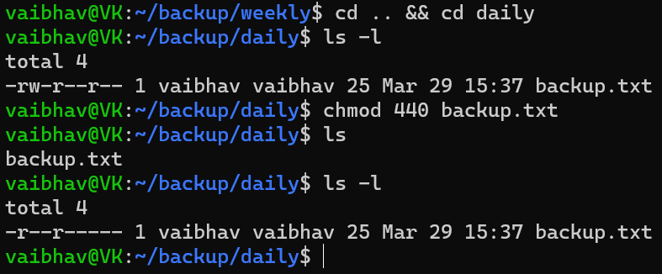

**Cloud**

1. **Create a linux EC2 and access the EC2 through putty on your system using .ppk file and then create a html page and make it available on a public IP address.**

Step 1 – Login and search for EC2 in services.

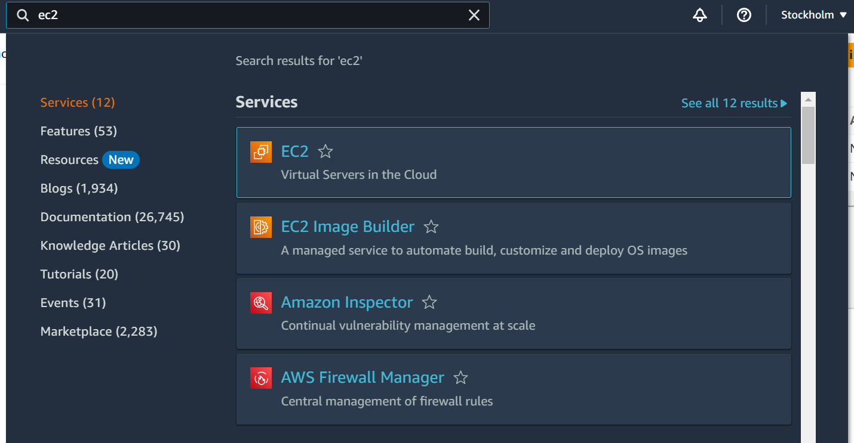



Step 2 – Goto the instances.

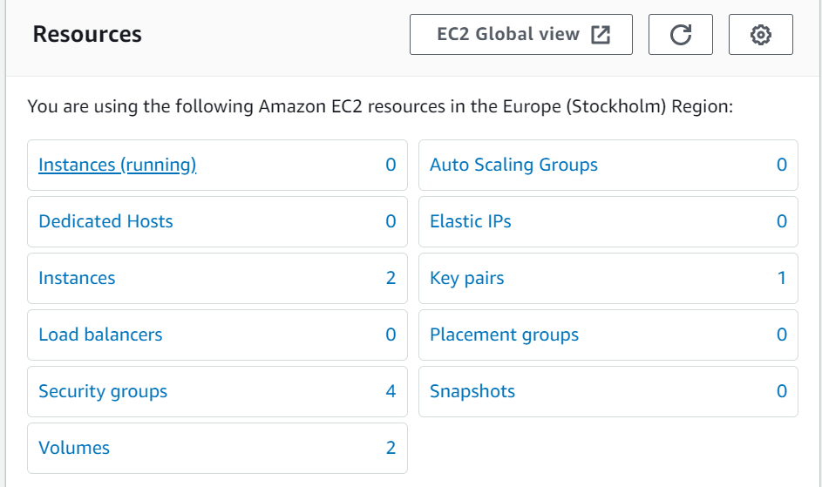



Step 3 – Then click on Launch instances button

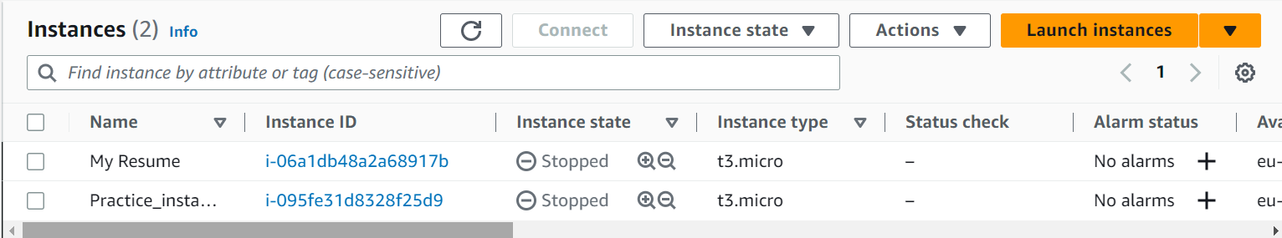



Step 4 – Give name to your instance

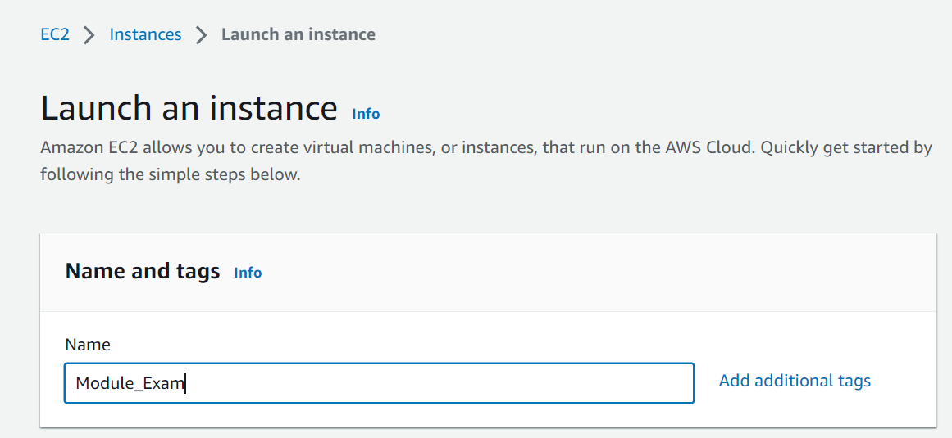



Step 5 – Select quick start operating system as per machine.

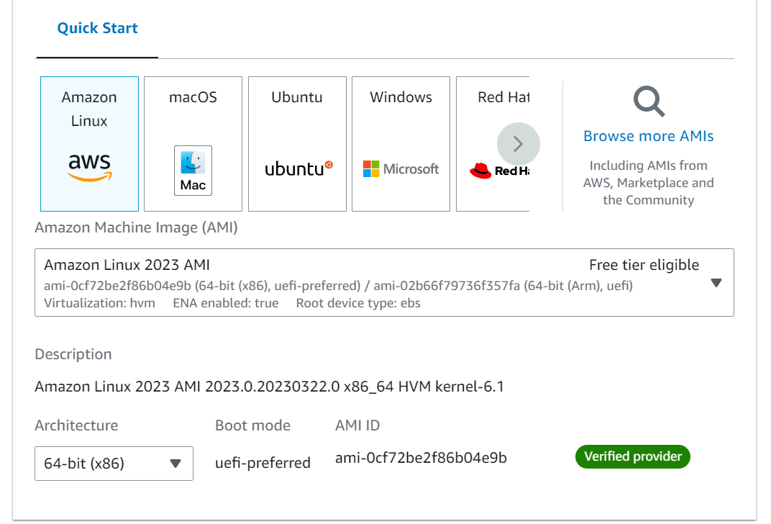



Step 6 – Select instance type as ‘free tier eligible’.

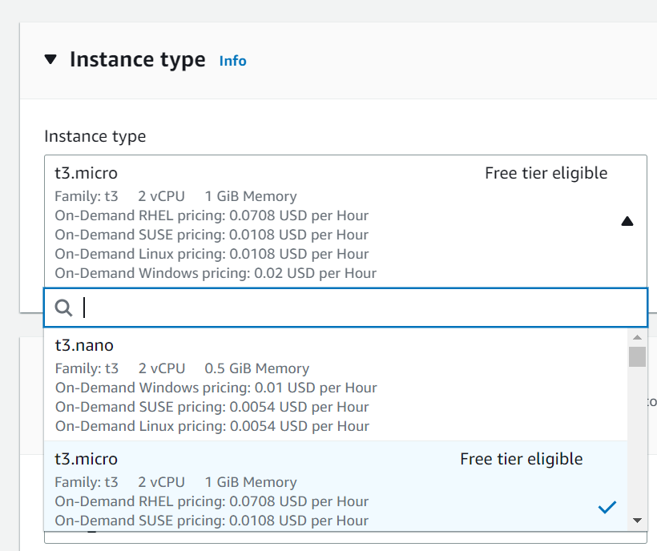



Step 7 – Select key pair name.

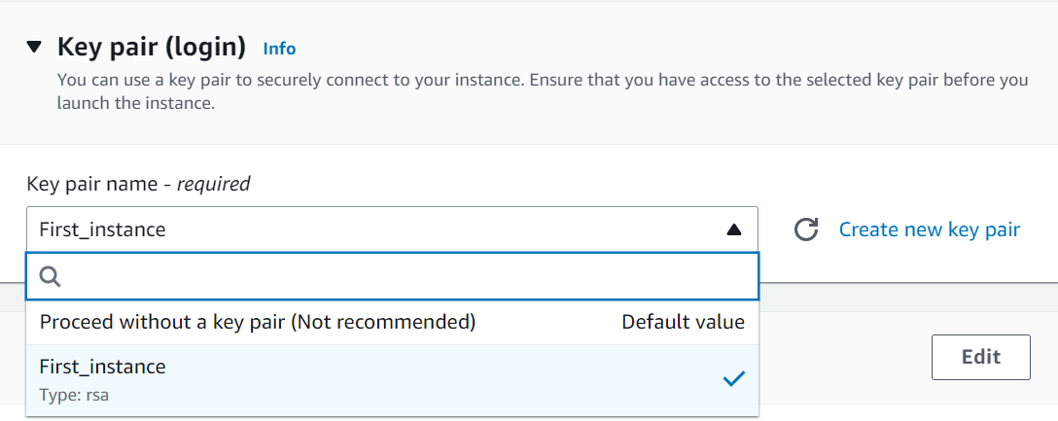

Step 8 – Tick checkboxes for allow SSH traffic from, allow HTTPS traffic from the internet, allow HTTP traffic from the internet.

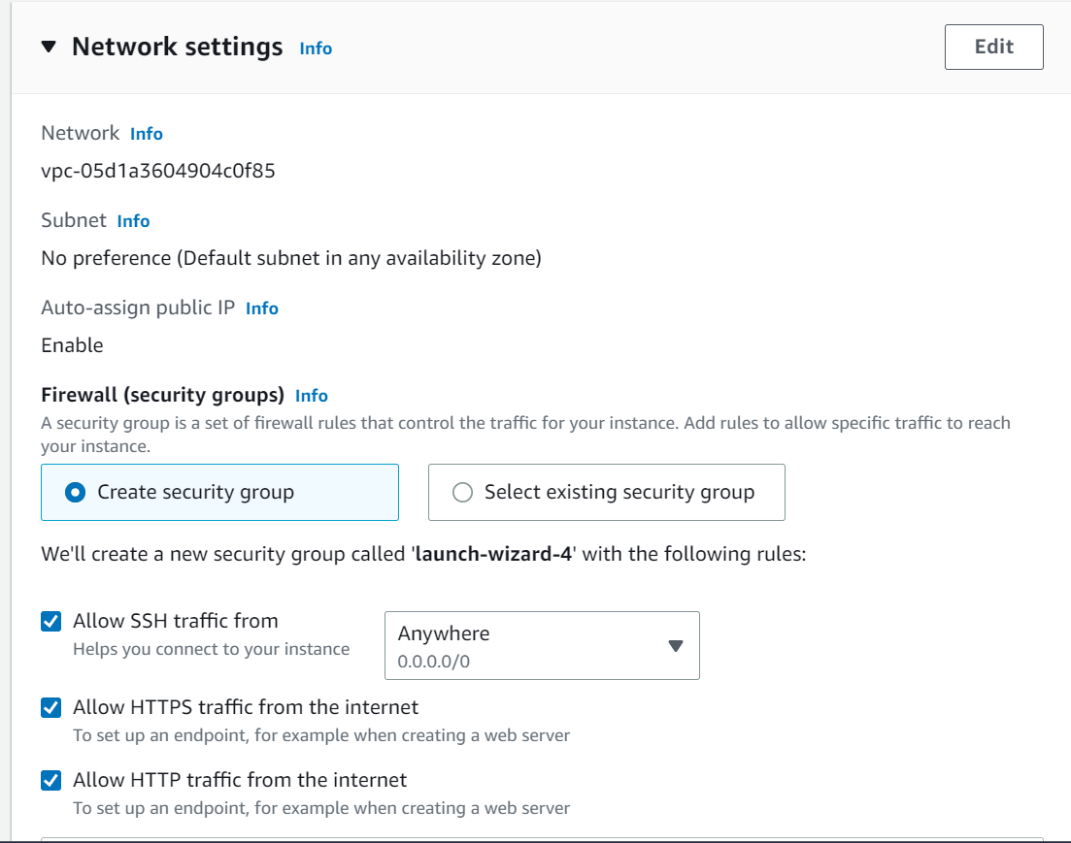



Step 9 – Configure storage as per your machine.

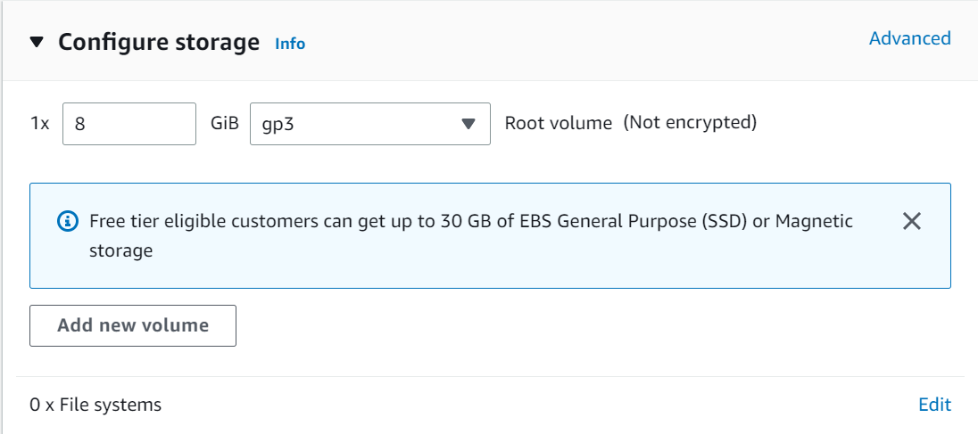

Step 10 – Review summary and click on launch instance button.

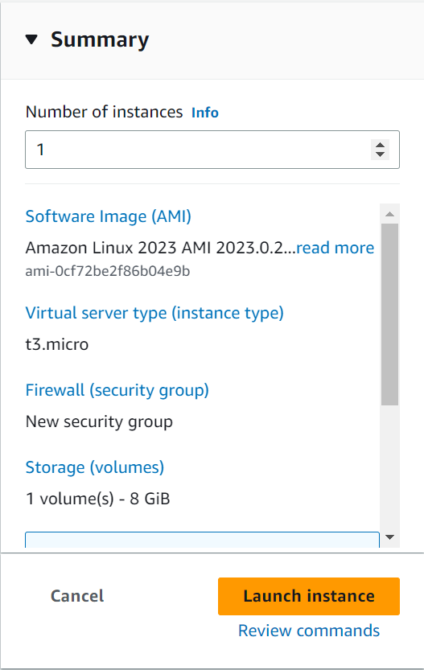



Step 11 – After succeed, go to the instance.

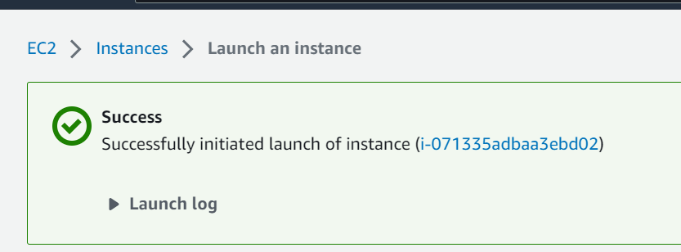



Step 12 – Click on instance ID which you have created.

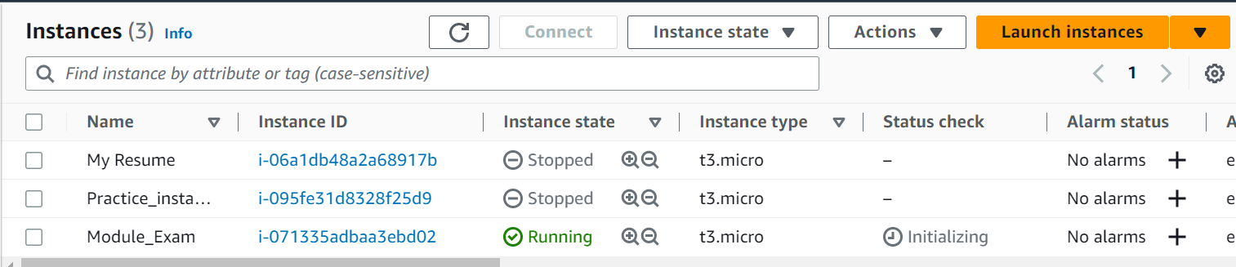



Step 13 – Copy Public IPv4 address.

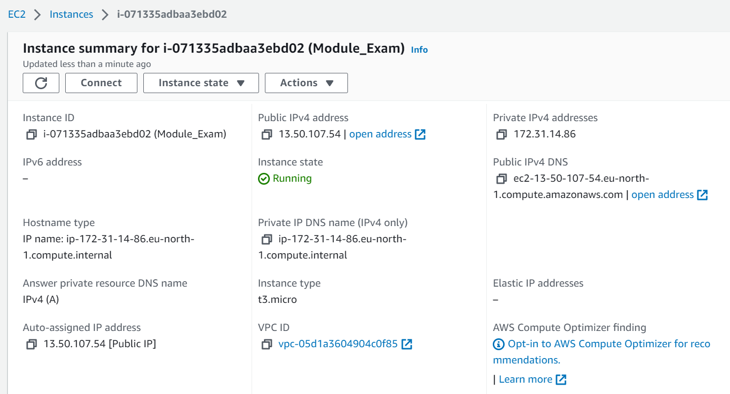



Step 14 – Open putty.

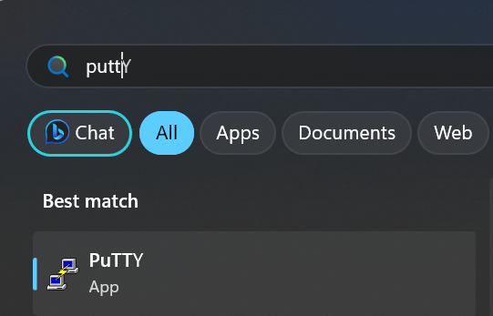



Step 15 – Enter host name as [ec2-user@13.50.107.54](mailto:ec2-user@13.50.107.54)

which is your username with your public ip address.

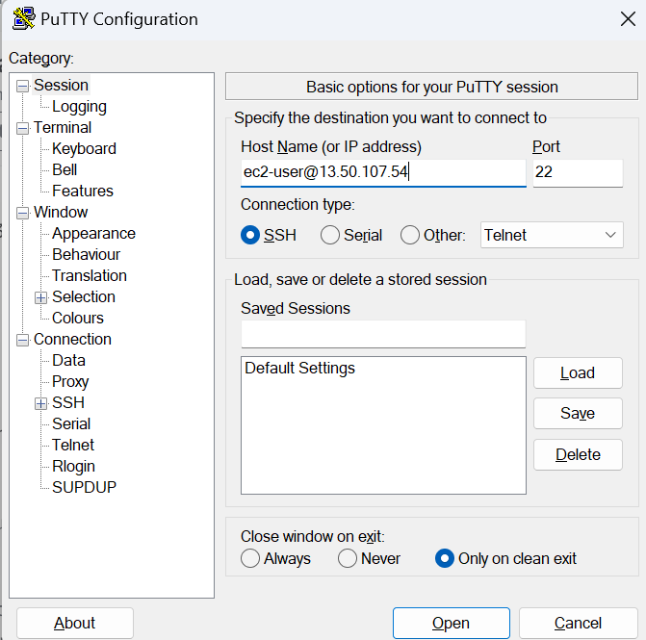



Step 16 – Then go to Connection >> SSH >>> AUTH >>> Credentials.

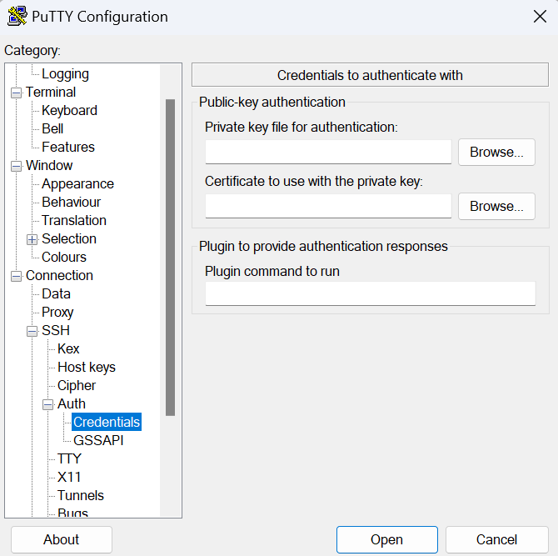



Step 17 – Then select instance.ppk file for both private key for authentication and certificate to use with the private key.

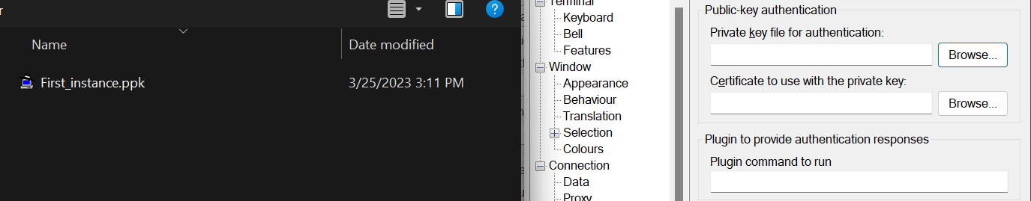



Step 18 – After selecting instance.ppk file for both the times, then click on Open.

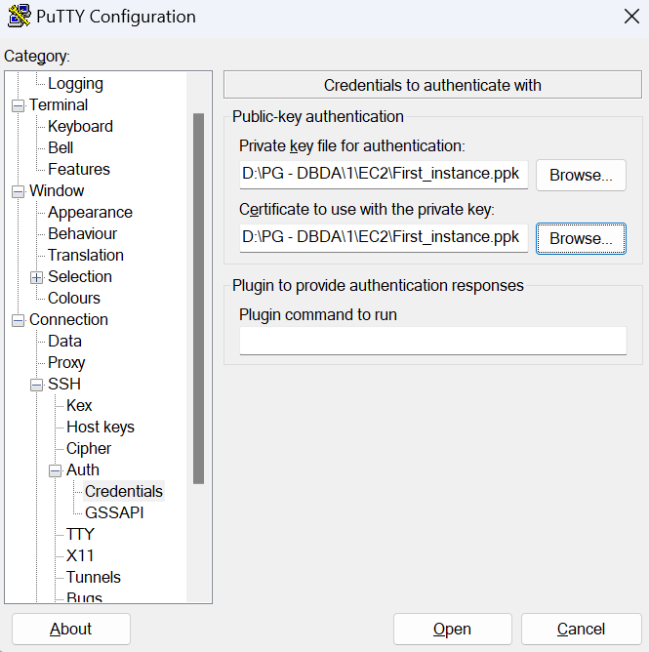



Step 19 – After here putty

Next steps -

1. sudo -i

This command will switch user to the root.

1. yum update -y

This command will update your packages upto the latest one.

1. yum install httpd -y

This command will install required httpd packages in your shell.

1. systemctl start httpd

This command will start your httpd package.

1. systemctl status httpd

This command will check status of your httpd package.

1. systemctl enable httpd

This command will enable httpd packages in your shell.

1. pwd

This command is used to print your working directory

1. cd /var/www/html

This command will move you to the html directory.

1. vim index.html

This command is used to create ‘index.html’ and it will be host on your public ip address.

1. index.html

In index.html you have to create code for webpage.

Eg.

<html>

<h1>

Hello Guys, Welcome to Cdac Mumbai.

</h1>

</html>

1. Open the following pasted public ip address to view the hosted page.(output)
2. 13.50.107.54
3. **Write a series of steps to create a new IAM user named jane, add the user to the devops group, give the user permissions to create new EC2 instances using IAM policy and verify the user’s permissions using IAM policy simulator.simulator.**

**Ans**

Step 1 – Login to your Amazon aws console and search for IAM.

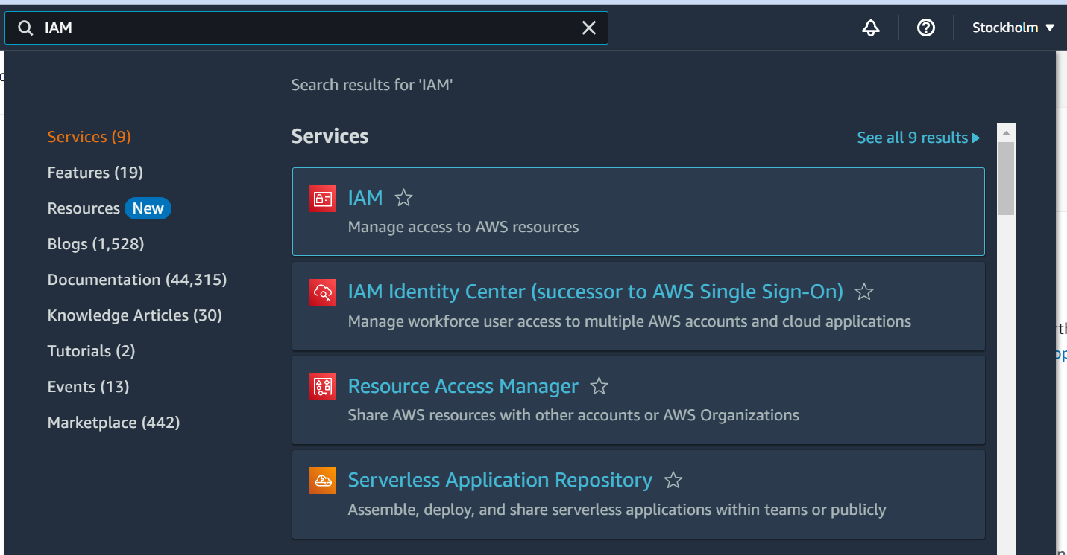



Step 2 – Complete your Root user MFA.

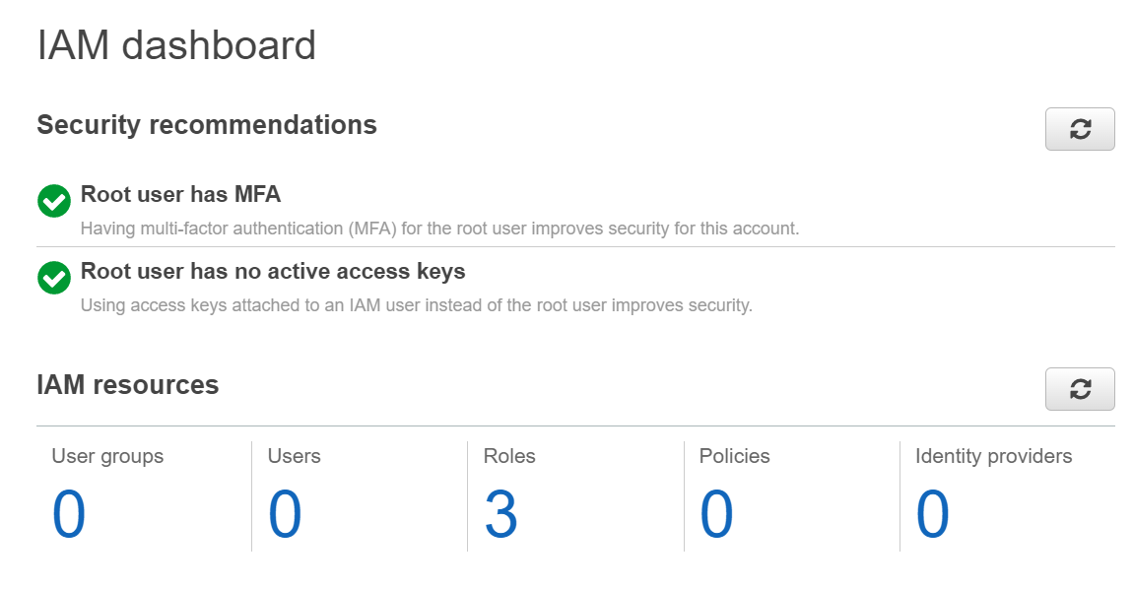

Step 3 – Click on Users.

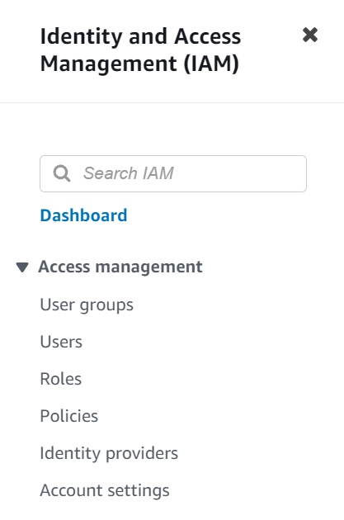



Step 4 – Click on ‘Add user’

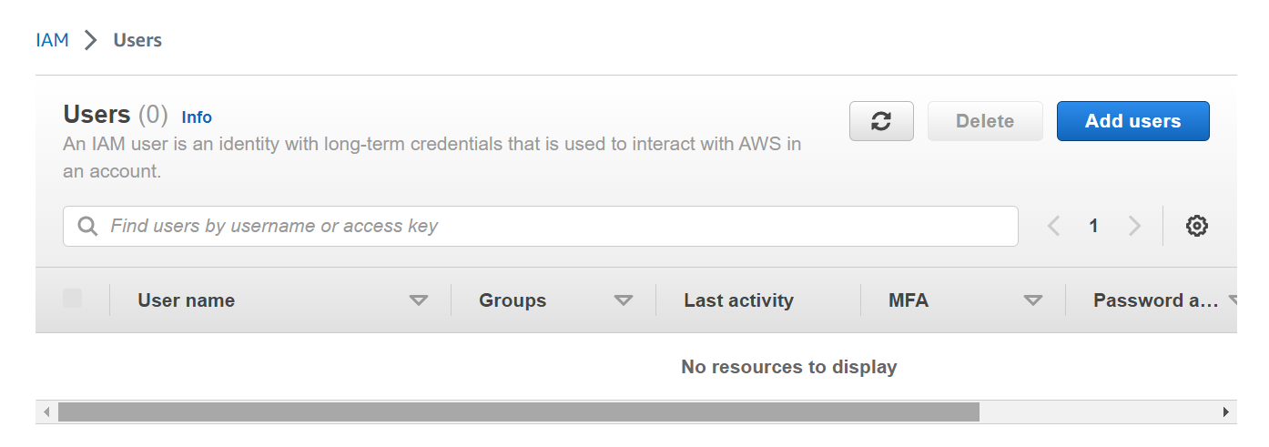



Step 5 – Enter username as mentioned as ‘jane’

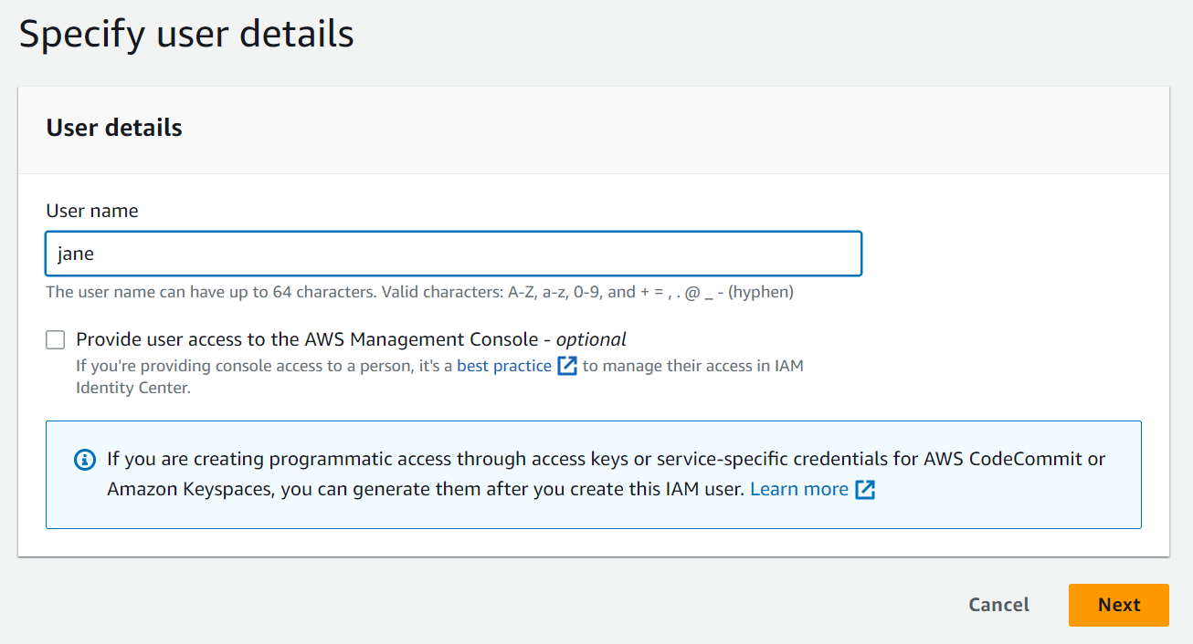

Step 6 – Select details for the user.

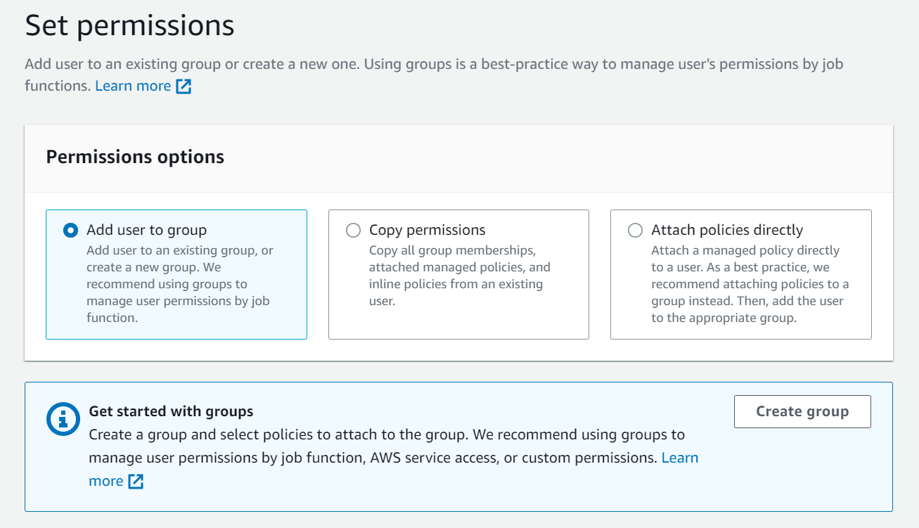

Step 7- Review your details.

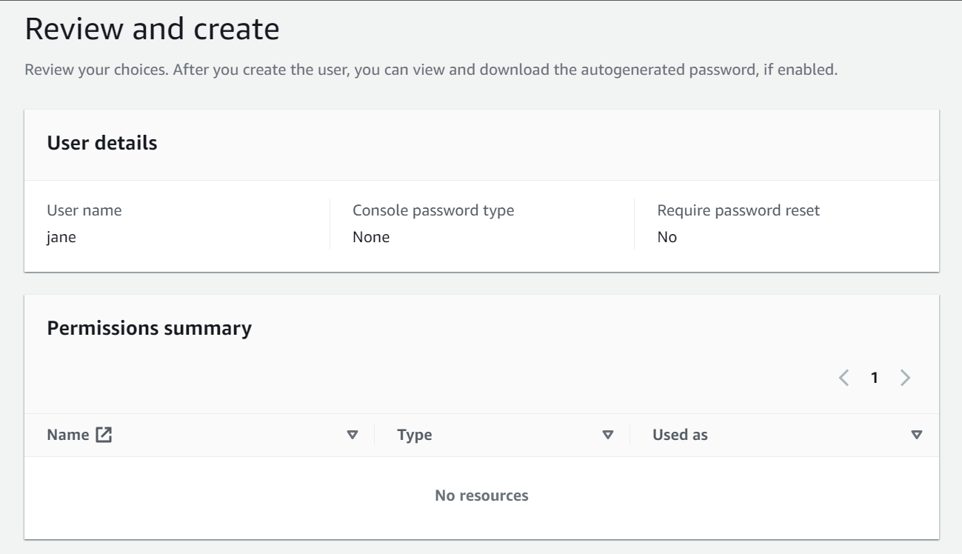

Step 8 – Then click on create user.

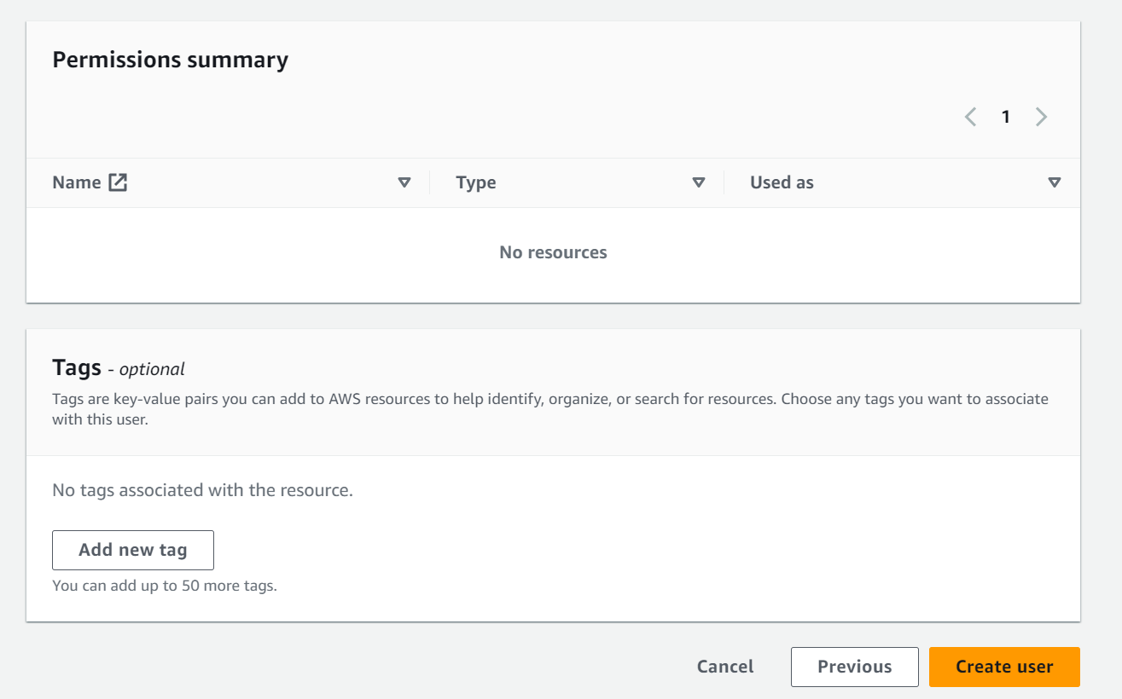

Step 9 – Click on user groups.

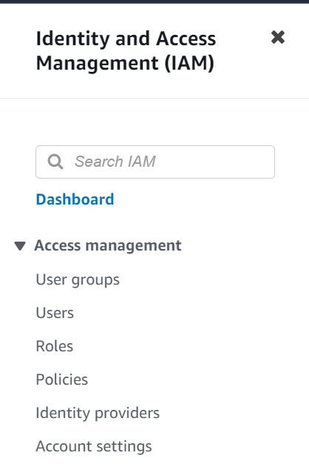

Step 10 - Click on create group

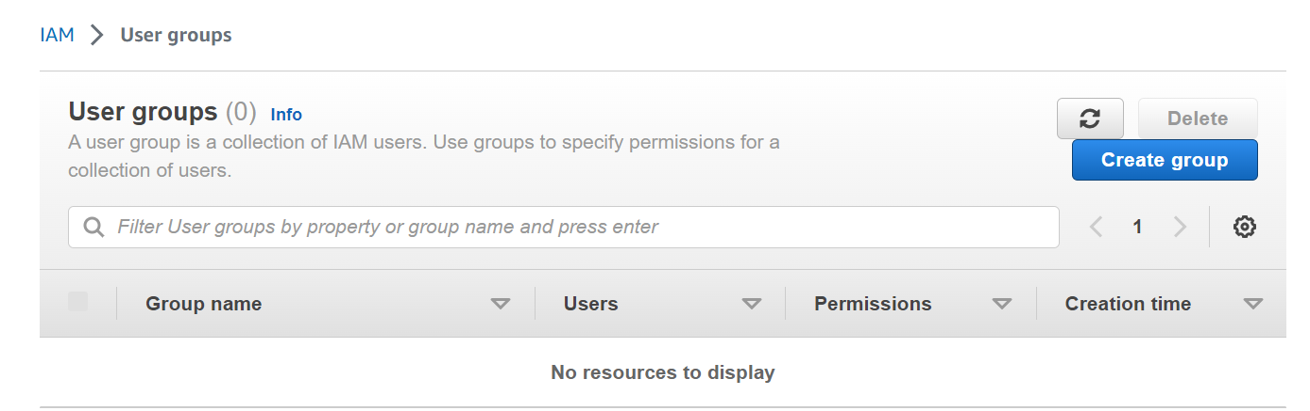

Step 11 – Name the group.

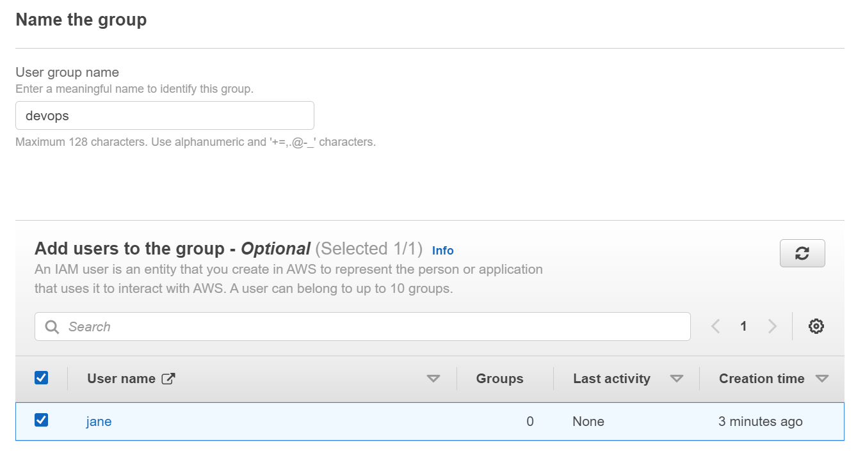

Step 12 – Attach permissions as per your requirement.

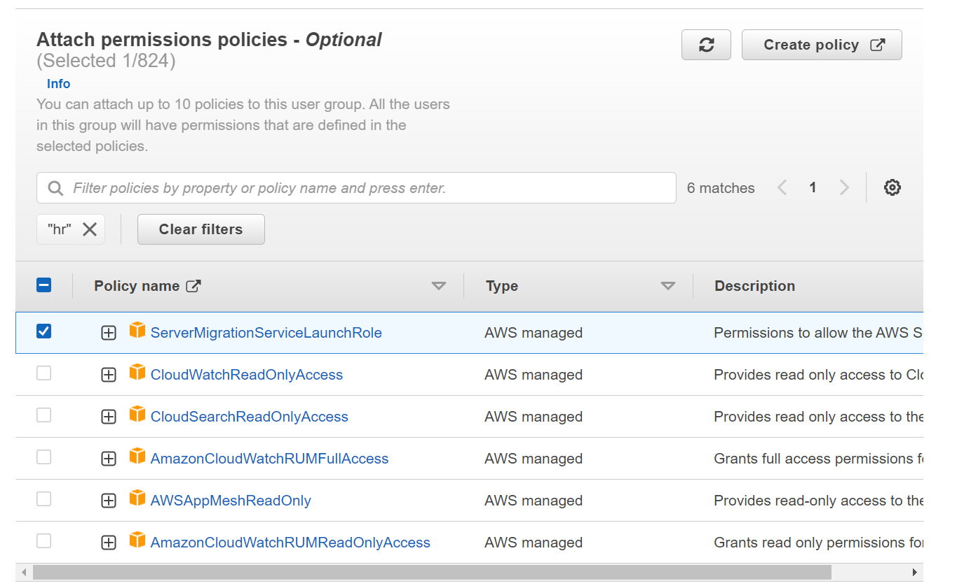

Step 13 – Open IAM policy simulator on web.

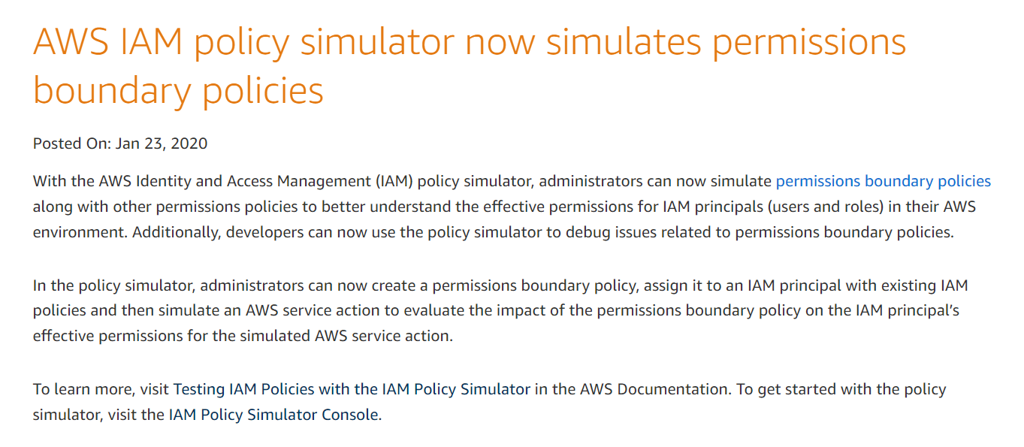

Step 14 – Select user.

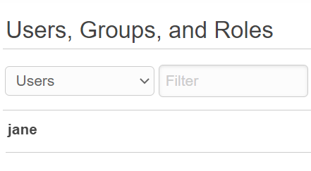

Step 15 – Search for EC2.

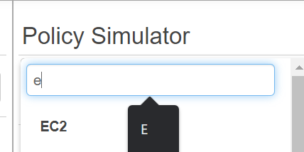

Step 16 – Then search for instances and select anyone.

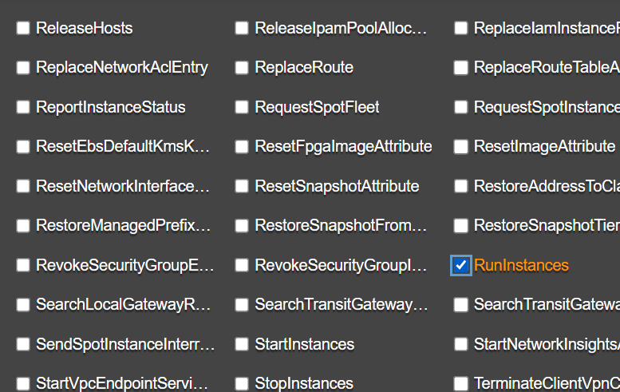

Step 19 – Then click on run simulation

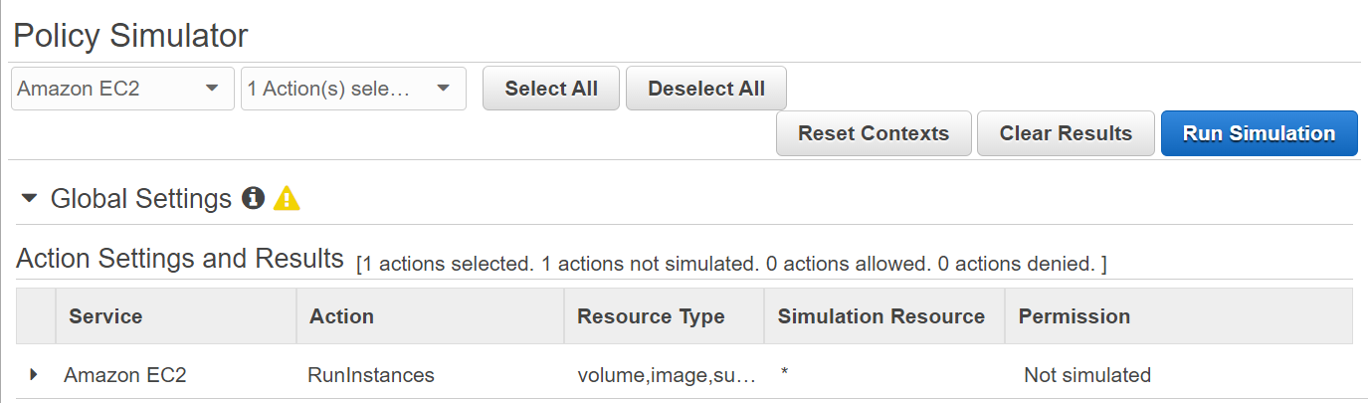



Step 20 - Output

